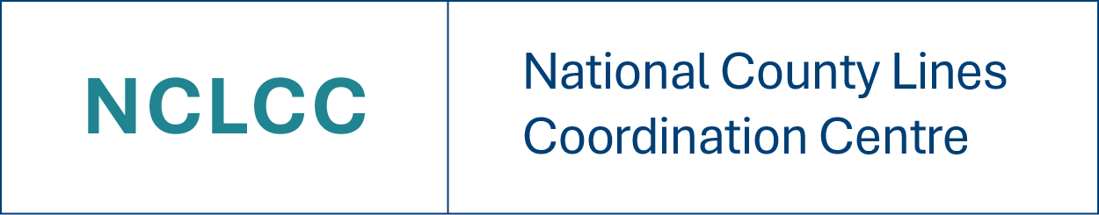
The NCLCC and strategic partners have developed a series of webinars covering a range of topics linked to county lines and CCE.
The webinars, when appropriate, will be recorded and can be accessed for up to 28 days after the event. To access the recording, you must sign up for the event via the link.

The next NCLCC national county lines awareness webinar is running on the 24th February. To register for this webinar please use the link below. As always we’re keeping it suitable for anyone involved in safeguarding roles (police, local authority staff, teachers, charities, voluntary organisations, faith groups etc).

The sign up link is here: NCLCC County Lines Awareness Webinar | Meeting-Join | Microsoft Teams

Our NCLCC regional Coordinators for the London regional are running an online conference, due to exceptional demand following in-person events. The conference will take place on the 18th March from 9am until 4pm. You can book on here: Select tickets –
National County Lines Coordination Centre Online Conference 2026 - County Lines and
Child Exploitation – Online Event

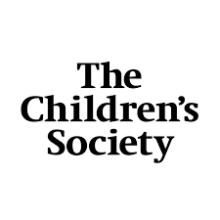
The Children’s Society’s next #LookCloser campaign will be taking place the week commencing March 2nd. We really look forward to sharing more information with yourselves soon about how to get involved.

During this week, we will be offering two online learning sessions on the connection between children going missing and different forms of exploitation.

Please follow the links to our Eventbrite to sign up for either of these sessions:

On March 3rd

On March 5th

There is also a session on #LookCloser: Overcoming gender assumptions to tackle child exploitation Tickets, Thu,
Mar 5, 2026 at 1:00 PM | Eventbrite

Parent / Carers Webinars:

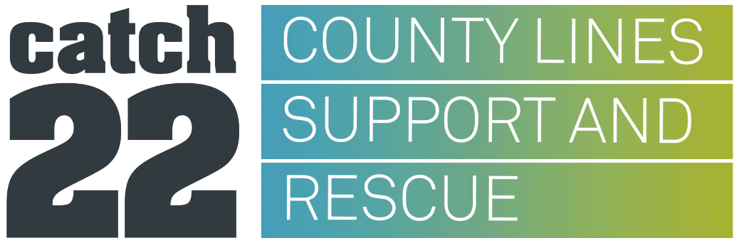

This session is aimed at parent/carers(including foster carers/grandparents) to gain a understanding on the important issues surrounding county lines, as well as the impact that it can have on young people and their families, and the support that is available to young people who are impacted/suffering from County Lines and Criminal Exploitation.

Topics will include:
- County Lines, child criminal exploitation (CCE) and financial exploitation,
- Stages of recruitment,
- Push and pull factors,
- The National Referral Mechanism,
- The Psychological impact
- Social media, Debt bondage, plus more

Dates/times with links

- Monday 2nd March 2026 (5.30pm -7pm) - https://www.eventbrite.co.uk/e/county-lines-awareness-webinar-for-parentcarers-only-tickets-1982277511398?aff=oddtdtcreator

- Thursday 5th March 2026(10am – 11.30pm) https://www.eventbrite.co.uk/e/county-lines-awareness-webinar-for-parentcarers-only-tickets-1982277709992?aff=oddtdtcreator

Confidentiality

Please note that you will not be able to discuss individual children/young people in this session due to confidentiality and safeguarding. However, if you need to speak to someone confidentially about an individual child or young person, we will be able to refer or signpost you to specialist advice during or following the session.

This session is for parents/carers only, if you are a professional and want to find out about other training/webinar that our available, please get in touch via our mailbox countylinessupportandrescue@catch-22.org.uk

Catch 22 – Knife Crime & County Lines
This session is aimed at parent/carers(including foster carers/grandparents) to gain a understanding on the important issues surrounding knife crime, county lines and how they interlink, as well as the impact and support that this has on young people and their families, affected by knife crime and county lines

Topics will include

- How county lines exploitation contributes to knife crime among young people.
- Identifying the common weapons involved
- Examines why these knives are chosen
- How the pressures of county lines activity normalise violence for exploited young people.
- The wider impact on communities and the serious legal consequences of knife possession and the importance of early intervention, education, and strong multi-agency safeguarding to prevent both exploitation and knife carrying.

Webinar Dates & Times:
- Monday 23rd February 10:30AM - 12:00PM - https://www.eventbrite.co.uk/e/knife-crime-county-lines-understanding-the-hidden-link-tickets-1982180735940?aff=oddtdtcreator

- Wednesday 4th March 16:30 - 18:00PM - https://www.eventbrite.co.uk/e/knife-crime-county-lines-understanding-the-hidden-linkparentscarers-tickets-1982181001735?aff=oddtdtcreator
Confidentiality

Please note that you will not be able to discuss individual children/young people in this session due to confidentiality and safeguarding. However, if you need to speak to someone confidentially about an individual child or young person, we will be able to refer or signpost you to specialist advice during or following the session.

This session is for parents/carers only, if you are a professional and want to find out about other training/webinar that our available, please get in touch via our mailbox countylinessupportandrescue@catch-22.org.uk


Ivison Trust Webinars

Child Exploitation and Missing From Home – Free parent webinar
These sessions are free and designed specifically for parents/carers.
They aim to help parents understand the links between children going missing and different forms of exploitation, including CCE and County Lines.

Purpose / Focus Areas
These sessions help parents/carers to understand:
- Why children go missing
- How missing episodes link to grooming and exploitation
- Warning signs and risk indicators
- How parents can be supported
- Where to seek additional help

Webinar: Child Exploitation and Missing From Home – Free parent webinar
Dates & Regions:

- 2 March 2026 – 7:00pm–8:30pm (North West) - https://ivisontrust-civi.org.uk/civicrm/event/register?reset=1&id=152

- 3 March 2026 – 1:00pm–2:30pm (South East) - https://ivisontrust-civi.org.uk/civicrm/event/register?reset=1&id=153

- 3 March 2026 – 7:00pm–8:30pm (West Midlands) - https://ivisontrust-civi.org.uk/civicrm/event/register?reset=1&id=154

- 10 March 2026 – 7:00pm–8:30pm (East Midlands) - https://ivisontrust-civi.org.uk/civicrm/event/register?reset=1&id=155

- 12 March 2026 – 1:00pm–2:30pm (Yorkshire & Humber) - https://ivisontrust-civi.org.uk/civicrm/event/register?reset=1&id=157

- 12 March 2026 – 7:00pm–8:30pm (South West) - https://ivisontrust-civi.org.uk/civicrm/event/register?reset=1&id=156

- 19 March 2026 – 1:00pm–2:30pm (North East) - https://ivisontrust-civi.org.uk/civicrm/event/register?reset=1&id=167

- 19 March 2026 – 7:00pm–8:30pm (East of England) - https://ivisontrust-civi.org.uk/civicrm/event/register?reset=1&id=159

- 26 March 2026 – 7:00pm–8:30pm (South Wales) - https://ivisontrust-civi.org.uk/civicrm/event/register?reset=1&id=163

- 27 March 2026 – 1:00pm–2:30pm (London) - https://ivisontrust-civi.org.uk/civicrm/event/register?reset=1&id=164

How professionals can support and work alongside parents of exploited and
missing children – Free webinar for professionals
13th March – 1pm-3pm: https://ivisontrust-civi.org.uk/civicrm/event/register?
reset=1&id=158
23rd March – 1pm-3pm: https://ivisontrust-civi.org.uk/civicrm/event/register?
reset=1&id=162

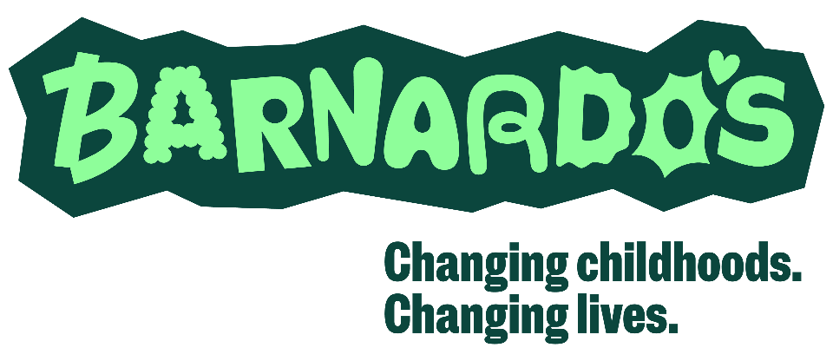

Barnardo's National Counter Trafficking Centre are offering a free programme of training
for practitioners working with children.
Sessions include:
- NRM Training
- Signs and Indicators of Exploitation and Trafficking in Children and Young People
- An Introduction to The Independent Child Trafficking Guardianship Service
- The Modern Slavery Act – Supporting Children in the Youth Justice System
- The Modern Slavery Act and section 45
- Undertaking Journey Work with Children
For more information and to sign up, visit: Training - NCTC - Barnardos

